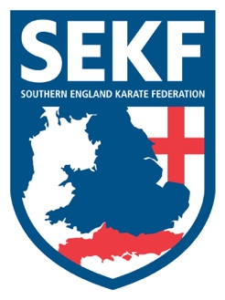
Newsletter January 2022

Dear parents and students,

I hope everyone enjoyed a peaceful Christmas break and managed to catch up safely with family and friends.

Congratulations to everyone who graded in December. Sensei Danny, Sasha and Debbie were very happy with everyone’s standard and most important great effort.

Just before Christmas I travelled to Las Vegas with Carla to compete in two international competitions, both were a great success for Team SEKF, and England as Carla managed to win a total of four medals.
In the first competition the Junior International cup, Carla won two silver medals, one in each discipline of kata and kumite. The 2nd competition was the prestigious USA Open which run over two days, Carla competed at her very best and managed to win a silver medal in the Cadet kumite +54k and a bronze in the Cadet Kata. The results are testament to Carla’s continued dedication and hard work combined with the great support she receives from Team SEKF. Thanks everyone.

Covid cases are seriously rising at present, therefore for the foreseeable future we need to continue to follow the SEKF Covid guidelines which have been updated for 2022 and can be found on our website at the bottom of the homepage, under downloads. I understand that there are many different views on the seriousness of Covid at present. However, the SEKF guidelines are in place to protect our students and Instructors to maintain a safe and healthy training environment.

Saturday grading course for all students

There will be a special grading course on Saturday 15th January to be held at New Milton Health & Leisure Centre, (Gore Road, New Milton. BH25 6RR)
This course will be aimed at learning the new kata for your next belt (or tag) and is important if you wish to grade in April.

White & Red belts: - 12.00 – 12.55pm
Yellow and Orange tag: - 1.00 – 1.55pm
Orange belt to blue tag. - 2.00 – 2.55pm
Blue belt and above. - 3.00 - 4.00pm

Advanced Course

There will be an advanced course on Sunday 16th January for Blue belt & above to be held at New Milton Health and Leisure Centre. (Gore road, BH25 6RR). This course will cover some exciting, advanced work including advanced Kata and knife defences.

Time: 11.30am – 1.30pm Cost: £16.00
Please make payment to the SEKF – Account: 03807886 - Sort Code: 20-96-96

If you would like further private tuition for the forthcoming grading in April, please do not hesitate to organise a date/time with Sensei Danny.

Sensei Collin - 07966 303 585 Sensei Danny - 07813 329 710
collinrudkin@gmail.com www.sekf.co.uk

