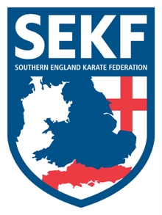
Open Squad Course and Selections '2022

The Southern England Karate Federation (SEKF) Open Squad Course and Selections are held just once a year for students from seven year’s old who are orange belt and above.
This course is designed to give students the chance to train with the current squad members whilst learning some very exciting and advanced techniques.

The selections are optional and give the more adventurous student the chance to compete for a place on our prestigious squad.
It is essential that all existing squad members attend to retain their place.

Prior to Covid in 2019, our hard-working SEKF athletes managed to win a respectable 13 Gold, 18 Silver and 25 Bronze medals at National and International level

This Course will take place on Sunday 30 January 2022, at New Milton Health & Leisure, Gore road, BH25 6RR.

REGISTRATION - 11.15am – 11.30am
COURSE - 11.30am - 1.30pm
BREAK - 1.30pm – 1.45pm
SELECTIONS - 1.45pm - 3.00pm (optional)

COST - £16.00 SELECTIONS - FREE
--------------------------------------------------------------------------------------------------------------

STUDENT NAME: ______________________________ AGE: _____Grade_________
PLEASE TICK: SQUAD TRAINING: £16.00________________
SQUAD SELECTIONS (Optional): FREE _______________

SIGNED: ____________________________ TOTAL PAID: ________________

Please WhatsApp the form and confirm payment to Sensei Collin on 07966 303 585.

Southern England Karate Federation – Account: 03807886 - Sort Code: 20-96-96

www.sekf.co.uk

