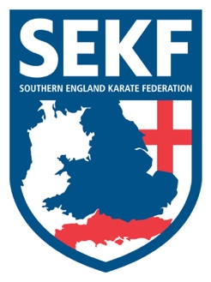
Newsletter May 2021
I hope everyone has enjoyed their return to club karate after such a long time online. I am sure I speak for all our SEKF instructors when I say it’s great to be back teaching in person.

Open squad session
There will be an Open Squad session on Sunday 9th May for students’ green belt & above to be held at New Milton Health & Leisure centre, (Gore road, New Milton. BH25 6RR)
Time: 11.15am – 2.15pm Cost: £15.00

Saturday grading course for all students
There will be a special grading course on Saturday 15th May to be held at New Milton Health & Leisure Centre, (Gore Road, New Milton. BH25 6RR)
This course will be aimed at learning and perfecting Kata and Basics for your next belt (or tag) and is vital if you wish to grade in July.

White belt to Orange tag - 1.00 – 1.50pm
Orange belt to Blue tag - 2.00 – 2.50pm
Blue belt to Brown tag - 3.00 – 3.50pm
Brown belt and above. - 4.00 - 5.00pm

Advanced Course
There will be an advanced course on Sunday 16th May for Blue belt & above to be held at New Milton Health and Leisure Centre. (Gore road, BH25 6RR). This course will cover some exciting advanced work including advanced kicks, fighting techniques and pad work. It is vital for students wishing to grade in July to attend.
Time: 11.15am – 1.15pm Cost: £15.00

If you would like further private tuition for the forthcoming grading in July, please do not hesitate to organise a date/time with Danny.

Sensei Collin - 07966 303 585 Sensei Danny - 07813 329 710
collinrudkin@gmail.com www.sekf.co.uk

