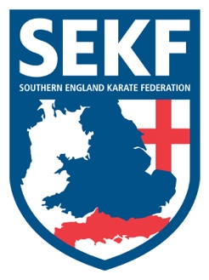
Newsletter
May 2022

Hi Parents / Students

Congratulations to Carla Rudkin-Guillen after winning the British Karate Championships and for being selected to represent England at the European Championships being held in Prague. All the hard work paying off…
Also, congratulations to Megan Barnes for winning a silver medal in the recent British championships. Well done!

Well done to Joe Langford, Maya and Oliver Chapman and George Palmer who raised the most money on the recent Fun Run for the 100 club. They will all enjoy a private karate lesson with Danny. Enjoy Guys!

Saturday grading course for all students
There will be a special grading course on Saturday 21st May to be held at New Milton Health & Leisure Centre, (Gore Road, New Milton. BH25 6RR)
This course will be aimed at learning the new Kata for your next belt (or tag) and is important if you wish to grade in April.

White & Red belts: - 12.00 – 12.55pm
Yellow belts - 1.00 – 1.55pm
Orange tag to blue tag. - 2.00 – 2.55pm
Blue belt and above. - 3.00 - 4.00pm

Advanced Course
There will be an advanced course on Sunday 22nd May for students’ blue belt and above to be held at New Milton Health and Leisure Centre. (Gore road, BH25 6RR). This course will cover some exciting, advanced work

Time: 11.30am – 1.30pm Cost: £16.00
Please make payment to the SEKF – Account: 03807886 - Sort Code: 20-96-96

Sensei Collin - 07966 303 585 Sensei Danny - 07813 329 710
collinrudkin@gmail.com www.sekf.co.uk

