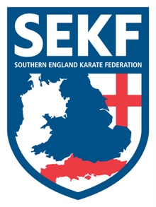
Covid-19 Risk Assessment

COVID RESTRICTIONS LIFTED MARCH 2022

This guidance is based upon best advice provided by, and is compliant with, UK government directives.
The principle aim of this guidance is to suspend current Covid restrictions. However, continue to safeguard against the potential spread of the COVID -19 virus

Preparation/Planning

SEKF instructors will ensure the following:

- Students’ who are diagnosed with Covid-19 are not allowed to attend any classes until recovered.
- Parents are now invited to spectate during Advanced courses, Squad sessions and gradings
- Safe and orderly entry and exit to the dojo observing social distancing protocols.
- Students should continue to observe social distancing where possible
- Members should arrive changed and ready where possible
- Sessions will be pre-booked
- Payments for sessions will be contactless where possible.
- The dojo will be ventilated where possible

Training/Practice

- Face covering are not compulsory at this time, but consideration must be given to their use.
- All equipment used will be sanitised after usage

