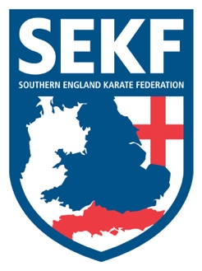
Newsletter November 2019
I hope you have all enjoyed a nice half term break.

Congratulations to our fantastic Squad, after winning a total of 4 Gold, 2 silver and 4 Bronze medals at the Elite International Open Championships.
Well done to everyone who attended the recent weekend Elite Kata and Kumite course with James Scanlon and his students
The above articles and other Forthcoming Events are on our website at www.sekf.co.uk

Saturday course for New Forest area students
There will be a special course on Saturday 9th November at New Milton Health & Leisure Centre, (Gore Road, New Milton BH25 6RR).
This course will be aimed at learning and perfecting the basics and fighting techniques for your next belt (or tag) and is vital if you wish to grade in December.

White & Red belts - 2.00 – 3.00pm
Yellow belt to Green tags - 3.00 – 4.00pm
Green belt & Above - 4.00 – 5.00pm

Saturday course for Poole area students
There will be a special course on Saturday 9th November at the Ashdown Leisure Centre, (Adastral Rd, Canford Heath. BH17 8PY).
This course will be aimed at learning and perfecting the basics and fighting techniques for your next belt (or tag) and is important if you wish to grade in December.

White to Green tag - 10.00am – 11.00am
Green Belt & Above - 11.00am – 12.00pm

Advanced Course
There will be an advanced course for Blue belt & above, and Squad members only, to be held at New Milton Health and Leisure Centre. (Gore road, BH25 6RR). This course is vital for advanced students wishing to grade in December.

Date: Sunday 10th November Time: 11.15am – 1.15pm Cost: £15.00

If you would like further private tuition for the forthcoming grading in December or to improve on kata / Kumite in preparation for the SEKF interclub competition, please do not hesitate to organise a date/time with Danny.
COLLIN - 07966 303 585 collinrudkin@gmail.com
DANNY - 07813 329 710

