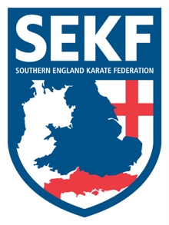
Open Squad Course and Selections '2020

The Southern England Karate Federation (SEKF) Open Squad Course and Selections are held just once a year for students from seven year’s old who are orange belt and above.
This course is designed to give students the chance to train with the current squad members whilst learning some very exciting and advanced techniques.

The selections are optional and give the more adventurous student the chance to compete for a place on our prestigious squad.
It is essential that all existing squad members attend to retain their place.

During 2019, our hard-working SEKF athletes managed to win a respectable 13 Gold, 18 Silver and 25 Bronze medals at National and International level

This Course will take place on Sunday 26th January 2020, at New Milton Health & Leisure, Gore road, BH25 6RR.

REGISTRATION - 11.00am – 11.15am
COURSE - 11.15am - 1.00pm
BREAK - 1.00pm – 1.15pm
SELECTIONS - 1.15pm - 3.15pm (optional)

COST - £15.00 SELECTIONS - FREE

…………please return slip below by Friday 24th January with full payment…………

STUDENT NAME: _______________________________ TEL: _____________

PLEASE TICK : SQUAD TRAINING: £15.00_______________
SQUAD SELECTIONS (Optional): FREE _______________

SIGNED: ____________________________ TOTAL PAID: ________________
(Please make cheques payable to SEKF)

www.sekf.co.uk

