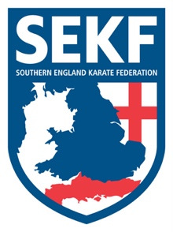
International Match

Squad Manager
Collin Rudkin
6Th Dan
Squad Coach Squad Captain
Danny Rudkin James Arnold
5th Dan 1st Dan

I have pleasure in announcing that all students’ blue belt and above, are invited to an International Karate Match with Fran Salazar and his students from Spain on Saturday 19th January 2019’ at New Milton Health & Leisure Centre, Gore road. BH25 6RR.

The International karate match will consist of both kata and kumite training. Students will receive a special certificate for attending.

REGISTRATION - 3.45pm – 3.55pm
KATA TRAINING - 4.00pm – 5.30pm
BREAK - 5.30pm – 6.00pm
KUMITE TRAINING - 6.00pm – 7.15pm
PHOTOS - 7.15pm – 7.30pm

COST - £20.00
ELITE SQUAD - £10.00

If you wish to participate in this exciting event, please return the slip below by Sunday 13th January with payment.
……………………………………………………………………………..

STUDENT NAME: _______________________________ TEL: _____________

INTERNATIONAL MATCH: £20.00_________

SIGNED: ____________________________ TOTAL PAID: ________________
(Please make cheques payable to SEKF)

Club Enquiries - collinrudkin@gmail.com
Collin - 07966 303 585

