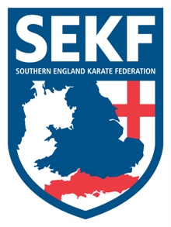

Primary School Payment Information

I hope everyone is enjoying their first half term of karate

The Primary school classes will resume week commencing Monday 1st November and run for six weeks, breaking up for Christmas week ending Friday 10th December.
Ashley Junior School will resume Monday 8th November and run for five weeks due to an inset day.

School fees – 6 weeks x £8.00 plus 2 Saturday grading courses = £64.00

Lymington JNR School = £56.00 - Lesson owed due to school closure 21st Oct
St Marks School (Friday class) - £56.00 – Lesson owed due to inset day 22nd Oct
Ashley Junior School - £56.00 – No Class Monday 1st November

Please note the grading course dates are Saturday 13th November and Saturday 4th December. These courses are designed to prepare the student for the actual grading which takes place on Sunday 12th December. (Further details will follow)

Students who train at the primary schools will automatically have their place reserved for the following half term. However, it is important to make payment by the due date Friday 29th October. After this date we will offer the spaces to students on our waiting list.

When making payment please use your child’s name and the school code as reference to avoid payment being missed.

School Codes: Ashley Junior School – AJS. / Bransgore School – BGS. / St Marks School – SMS. Milford School – MS. / Burton School – BS. / St Luke’s School – SLS / Lymington JNR School – LJS / Twynham School – TS / St James school – SJS

Bank Details
Name: Freestyle Combat Karate Club
Account No: 50134759
Sort Code: 20-68-79

If any parents are struggling financially or require further information, please contact Sensei Collin direct on 07966 303 585
Please find all the latest news and events on our website at www.sekf.co.uk

