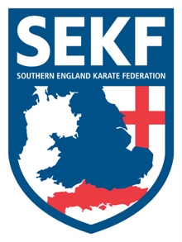
Open Squad Course and Selections '2019

The Southern England Karate Federation (SEKF) Open Squad Course and Selections are held just once a year for students from seven year’s old who are orange belt and above.
This course is designed to give students the chance to train with the current squad members whilst learning some very exciting and advanced techniques.

The selections are optional and designed to give the more adventurous student the chance to compete for a place on our prestigious squad.
It is essential that all existing squad members attend to retain their place.

During 2018, our hard-working SEKF athletes managed to win a respectable 19 Gold, 19 Silver and 20 Bronze medals at National and International level

This Course will take place on Sunday 27th January 2019, at New Milton Health & Leisure, Gore road, BH25 6RR.

REGISTRATION - 11.00am – 11.15am
COURSE - 11.15am - 1.15pm
BREAK - 1.15pm – 1.30pm
SELECTIONS - 1.30pm - 4.15pm (optional)

COST - £15.00 SELECTIONS - FREE

I am looking forward to seeing some new fresh and ambitious students for the Year 2019!

Club Enquiries - collinrudkin@gmail.com
Collin - 07966 303585
Danny - 07813 329710
www.sekf.co.uk

