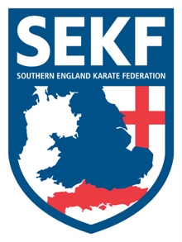
Special Karate Course

It is with great honour to announce that Nine times World Champion ‘Wayne Otto O.B.E’ the Norwegian National Coach will be running a kumite course for the SEKF.
As a competitor Wayne Otto dominated his weight category winning gold medals at English, British, European and World level. At present Wayne is the Norwegian National Kumite Coach and boasts helping Norway to their first Olympic gold medal at the Youth Olympics in Buenos Aires 2018.

This course will include all aspects of kumite training and is open to student’s Orange belt and above.
There will be three sessions throughout the day. The first session is for student’s Orange belt above plus squad members, the 2nd session is for squad members only, whilst the last session is for Elite and A’ squad.

This Kumite course which has been part funded by the SEKF will be held on Sunday 28th April at New Milton Health & Leisure Centre, (Priestlands school gym), North street, SO41 8FZ

Registration - 11.00am – 11.15am Session one for Orange belt and above - 11.15am – 12.45pm
BREAK - 12.45pm – 1.00pm
Session two for squad members only - 1.00pm – 2.30pm
BREAK - 2.30pm – 2.45pm
Session three for Elite and K1 Squad - 2.45pm – 4.00pm

COURSE COST - Session one only - £15.00
Squad members - £25.00

…..……………. please return slip below by Friday 26th April with full payment ……………...

STUDENT NAME: _______________________________ TEL: _____________
PLEASE TICK : SESSION ONE ONLY: £15.00_______________

SQUAD MEMBERS: £25.00_______________

SIGNED: ____________________________ TOTAL PAID: ________________ (Please make cheques payable to SEKF)

