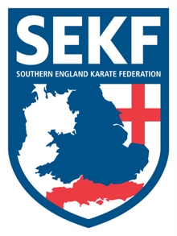
Kumite and Kata Weekend Course

Invite for Elite and A’ squad members

Dear Squad members,

Our Elite and A’ Squad members have an exciting opportunity to train alongside England Kata Team member, James Scanlon and his students. James and I will be jointly running a weekend kumite and kata course. The course will consist of two kumite sessions on the Saturday, followed by two kata sessions on the Sunday. In addition, the squad members will meet up Saturday evening for a fun time with James’s squad members.

DATE - Saturday 18th / Sunday 19th May 2019

VENUE - Hotel: Premier Inn, Thirsk. (To be confirmed)
Training: East Thirsk Community Hall, Hambleton Place. YO71SL

COST -
Travel - £30.00
Hotel - £35.00
Training fees - Sponsored by the 100 Club

Total - £65.00

Please confirm via email by Saturday 6th April…Payment is due Saturday 27th April

MEETING POINT

Rownhams Service Station – Saturday 18th May – 8.45am Sharp!

Return home – Sunday 19th May – Approx. 7.30pm.

If any parents wish to attend this trip or have any queries, please contact me direct.

Collin - 01202 893 633 - 07966 303 585
collinrudkin@gmail.com

