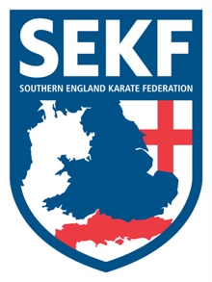
Special Karate Course

I am happy to announce that World Champion ‘Jordan Thomas will be running a kumite course for the SEKF.
Jordan is a current competitor on the world stage and is very exciting to watch when he demonstrates technical karate so don’t miss the chance to train at this exclusive SEKF event.
This course will include all aspects of kumite training and is open to student’s orange belt and above.
There will be three sessions throughout the day. The first session is for student’s orange belt above plus squad members, the 2nd session is for squad members only, whilst the last session is invited only.

This Kumite course which has been part funded by the SEKF will be held on Sunday 26th September at New Milton Health & Leisure Centre, Gore Road. BH25 6RR

Session one for orange belt and above: - 12.00pm – 1.45pm

Session two for squad members: - 2.00pm – 3.15pm

Session three invite only: - 3.30pm – 4.30pm

COURSE COST - Session one only - £15.00
Squad members (two sessions) - £25.00
…..………………………………………………………………………………………………………...

STUDENT NAME: _______________________________ TEL: _____________
PLEASE TICK: SESSION ONE ONLY: £15.00_______________
SQUAD MEMBERS: £25.00 _______________
SIGNED: ____________________________ TOTAL PAID: ________________

Please return the form via WhatsApp with confirmation of payment to Sensei Collin on 07966 303 585 by Friday 24th September

! Please make payment to Freestyle Combat Karate – 50134759 – 20-68-79

